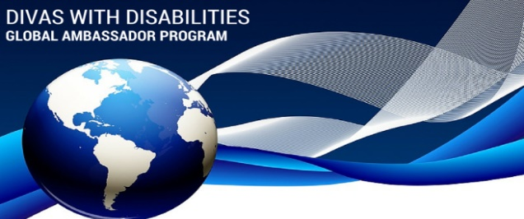
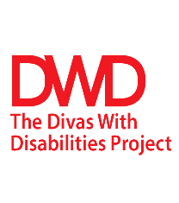

"A Diva State of Mine"
About the Initiative
The “Diva State of Mine” initiative was created by Diva, Cherri King for The Divas With Disabilities Global Diva Ambassador Program (GDAP).
The goal of this initiative is to increase awareness of The Divas With Disabilities Project (DWD) by sharing its purpose, mission and vision with Divas throughout their respective organization(s) and community.
The Concept behind the Initiative
Within the Diva State of Mine’s title, there are two terms, state and mine, that have dual definitions.
- State: geographical location; the place of residence. (2) Psychological level of cognition; frame of mind; feelings.
- Mine/Min’: (1) ownership; belonging to; where you live. (2) Jargon for “mind”=min’

What needs to be done?
- Organizing small groups, (events must have at least five (5) participants), comprised of Divas from various professions and communities at least twice a month (meeting frequency of the groups is flexible).
- Recruiting members to join the DWD movement.
- Planning and organizing events that solicit donations for DWD. This will be achieved by organizing small group events with women of color (Divas) with disabilities from various industries at least twice a month.

